**Ministry of Culture, Govt. of India and Department of Public Enterprises (DPE), Ministry of Finance, Govt. of India felicitated IIFCL for its CSR initiatives.**

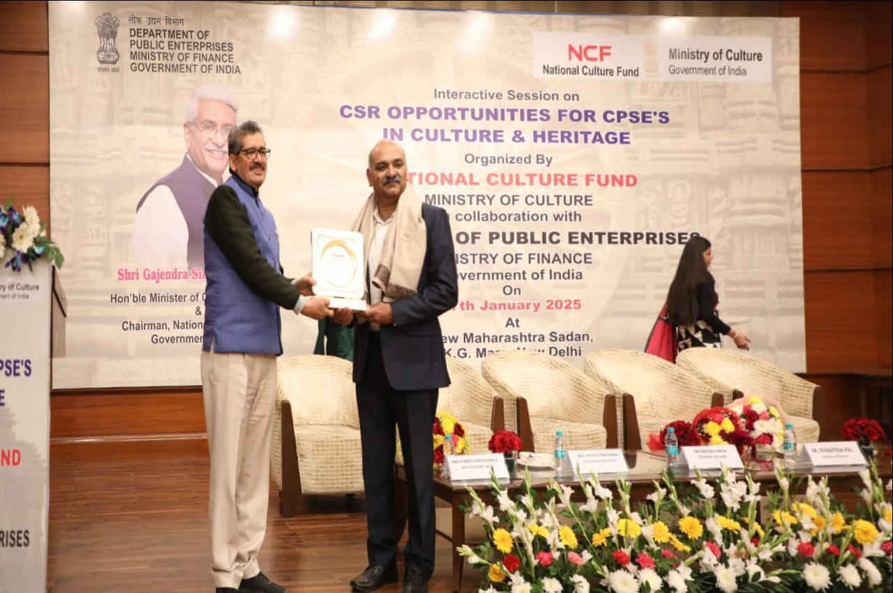

Ministry of Culture, Government of India in collaboration with the Department of Public Enterprises (DPE) felicitated IIFCL at an event on 17th January 2025, for our patronage in preservation of National Heritage and Culture through CSR.

Key initiatives of IIFCL in the mentioned theme area includes installation of e-ticketing machines at major ASI Monuments (Taj Mahal, Red Fort, etc.) and creating replica of 120 Feet Flag Post at Rashtrapati Nilayam. The award was collected by Shri Subodh Sharma, CGM & HoD (CSR).